**COM 431E: DATA WAREHOUSING AND MINING**

**Chapter One-Data mining**

**1.1 Introduction to Data Mining**

Data mining means extracting or mining knowledge from large amounts of data.

The term data mining is actually a misnomer. Thus, data mining should have been more appropriately named as knowledge mining which emphasis on mining from large amounts of data.

Extracting and ‘Mining’ knowledge from large amounts of data.

“Gold Mining from rock or sand” is same as “Knowledge mining from data”

It is the computational process of discovering patterns in large data sets involving methods at the intersection of artificial intelligence, machine learning, statistics, and database systems. The overall goal of the data mining process is to extract information from a data set and transform it into an understandable structure for further use.

Major Sources of Abundant data:

- Business – Web, E-commerce, Transactions, Stocks

- Science – Remote Sensing, Bio informatics, Scientific Simulation

- Society and Everyone – News, Digital Cameras, You Tube

* Need for turning data into knowledge – Drowning in data, but starving for knowledge

* Applications that use data mining:

- Market Analysis - Fraud Detection - Customer Retention

- Production Control - Scientific Exploration

The key properties of data mining are:

 Automatic discovery of patterns

 Prediction of likely outcomes

 Creation of actionable information

 Focus on large datasets and databases

**1.2 The Scope of Data Mining**

Data mining derives its name from the similarities between searching for valuable business information in a large database — for example, finding linked products in gigabytes of store scanner data — and mining a mountain for a vein of valuable ore. Both processes require either sifting through an immense amount of material, or intelligently probing it to find exactly where the value resides. Given databases of sufficient size and quality, data mining technology can generate new business opportunities by providing these capabilities:

**Automated prediction of trends and behaviors.** Data mining automates the process of finding predictive information in large databases. Questions that traditionally required extensive hands- on analysis can now be answered directly from the data — quickly. A typical example of a predictive problem is targeted marketing. Data mining uses data on past promotional mailings to identify the targets most likely to maximize return on investment in future mailings. Other predictive problems include forecasting bankruptcy and other forms of default, and identifying segments of a population likely to respond similarly to given events.

**Automated discovery of previously unknown patterns.** Data mining tools sweep through databases and identify previously hidden patterns in one step. An example of pattern discovery is the analysis of retail sales data to identify seemingly unrelated products that are often purchased together. Other pattern discovery problems include detecting fraudulent credit card transactions and identifying anomalous data that could represent data entry keying errors.

**1.3 Tasks of Data Mining**

Data mining involves six common classes of tasks:

* **Anomaly detection (Outlier/change/deviation detection)** – The identification of unusual data records, that might be interesting or data errors that require further investigation.
* **Association rule learning (Dependency modelling)** – Searches for relationships between variables. For example, a supermarket might gather data on customer purchasing habits. Using association rule learning, the supermarket can determine which products are frequently bought together and use this information for marketing purposes. This is sometimes referred to as market basket analysis.
* **Clustering** – is the task of discovering groups and structures in the data that are in some way or another "similar", without using known structures in the data.
* **Classification** – is the task of generalizing known structure to apply to new data. For example, an e-mail program might attempt to classify an e-mail as "legitimate" or as "spam".
* **Regression** – attempts to find a function which models the data with the least error.
* **Summarization** – providing a more compact representation of the data set, including visualization and report generation.

**1.4 Architecture of Data Mining System**

A typical data mining system may have the following major components.

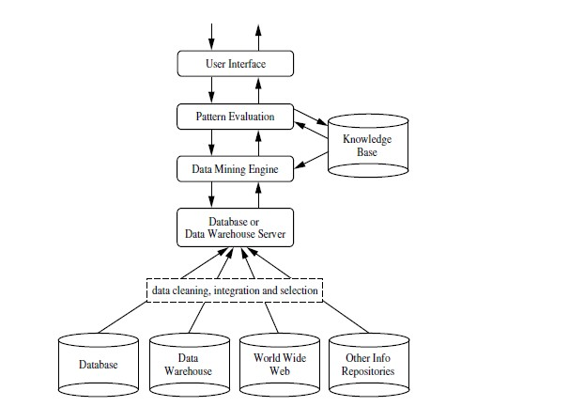

**1. Knowledge Base:**

This is the domain knowledge that is used to guide the search or evaluate the interestingness of resulting patterns. Such knowledge can include concept hierarchies, used to organize attributes or attribute values into different levels of abstraction. Knowledge such as user beliefs, which can be used to assess a pattern’s interestingness based on its unexpectedness, may also be included. Other examples of domain knowledge are additional interestingness constraints or thresholds, and metadata (e.g., describing data from multiple heterogeneous sources).

**2. Data Mining Engine:**

This is essential to the data mining system and ideally consists of a set of functional modules for tasks such as characterization, association and correlation analysis, classification, prediction, cluster analysis, outlier analysis, and evolution analysis.

**3. Pattern Evaluation Module:**

This component typically employs interestingness measures interacts with the data mining modules so as to focus the search toward interesting patterns. It may use interestingness thresholds to filter out discovered patterns. Alternatively, the pattern evaluation module may be integrated with the mining module, depending on the implementation of the datamining method used. For efficient data mining, it is highly recommended to push the evaluation of pattern interestingness as deep as possible into the mining process so as to confine the search to only the interesting patterns.

**4. User interface:**

This module communicates between users and the data mining system, allowing the user to interact with the system by specifying a data mining query or task, providing information to help focus the search, and performing exploratory datamining based on the intermediate data mining results. In addition, this component allows the user to browse database and data warehouse schemas or data structures, evaluate mined patterns, and visualize the patterns in different form

**1.5 Data Mining Process:**

Data Mining is a process of discovering various models, summaries, and derived values from a given collection of data.

The general experimental procedure adapted to data-mining problems involves the following

steps:

**1. State the problem and formulate the hypothesis**

Most data-based modeling studies are performed in a particular application domain. Hence, domain-specific knowledge and experience are usually necessary in order to come up with a meaningful problem statement. Unfortunately, many application studies tend to focus on the data-mining technique at the expense of a clear problem statement. In this step, a modeler usually specifies a set of variables for the unknown dependency and, if possible, a general form of this dependency as an initial hypothesis. There may be several hypotheses formulated for a single problem at this stage. The first step requires the combined expertise of an application domain and a data-mining model. In practice, it usually means a close interaction between the data-mining expert and the application expert. In successful data-mining applications, this cooperation does not stop in the initial phase; it continues during the entire data-mining process.

**2. Collect the data**

This step is concerned with how the data are generated and collected. In general, there are two distinct possibilities. The first is when the data-generation process is under the control of an expert (modeler): this approach is known as a designed experiment. The second possibility is when the expert cannot influence the data- generation process: this is known as the observational approach. An observational setting, namely, random data generation, is assumed in most data-mining applications. Typically, the sampling distribution is completely unknown after data are collected, or it is partially and implicitly given in the data-collection procedure. It is very important, however, to understand how data collection affects its theoretical distribution, since such a priori knowledge can be very useful for modeling and, later, for the final interpretation of results. Also, it is important to make sure that the data used for estimating a model and the data used later for testing and applying a model come from the same, unknown, sampling distribution. If this is not the case, the estimated model cannot be successfully used in a final application of the results.

**3. Preprocessing the data**

In the observational setting, data are usually "collected" from the existing databases, data warehouses, and data marts. Data preprocessing usually includes at least two common tasks:

**1. Outlier detection (and removal)** – Outliers are unusual data values that are not consistent with most observations. Commonly, outliers result from measurement errors, coding and recording errors, and, sometimes, are natural, abnormal values. Such nonrepresentative samples can seriously affect the model produced later. There are two strategies for dealing with outliers:

a). Detect and eventually remove outliers as a part of the preprocessing phase, or

b). Develop robust modeling methods that are insensitive to outliers.

**2. Scaling, encoding, and selecting features** – Data preprocessing includes several steps such as variable scaling and different types of encoding. For example, one feature with the range [0, 1] and the other with the range [−100, 1000] will not have the same weights in the applied technique; they will also influence the final data-mining results differently. Therefore, it is recommended to scale them and bring both features to the same weight for further analysis. Also, application-specific encoding methods usually achieve dimensionality reduction by providing a smaller number of informative features for subsequent data modeling.

These two classes of preprocessing tasks are only illustrative examples of a large spectrum of preprocessing activities in a data-mining process.

Data-preprocessing steps should not be considered completely independent from other data-mining phases. In every iteration of the data-mining process, all activities, together, could define new and improved data sets for subsequent iterations. Generally, a good preprocessing method provides an optimal representation for a data-mining technique by incorporating a priori knowledge in the form of application-specific scaling and encoding.

**4. Estimate the model**

The selection and implementation of the appropriate data-mining technique is the main task in this phase. This process is not straightforward; usually, in practice, the implementation is based on several models, and selecting the best one is an additional task. The basic principles of learning and discovery from data are given in Chapter 4 of this book. Later, Chapter 5 through 13 explain and analyze specific techniques that are applied to perform a successful learning process from data and to develop an appropriate model.

**5. Interpret the model and draw conclusions**

In most cases, data-mining models should help in decision making. Hence, such models need to be interpretable in order to be useful because humans are not likely to base their decisions on complex "black-box" models. Note that the goals of accuracy of the model and accuracy of its interpretation are somewhat contradictory. Usually, simple models are more interpretable, but they are also less accurate. Modern data-mining methods are expected to yield highly accurate results using high dimensional models. The problem of interpreting these models, also very important, is considered a separate task, with specific techniques to validate the results. A user does not want hundreds of pages of numeric results. He does not understand them; he cannot summarize, interpret, and use them for successful decision making.

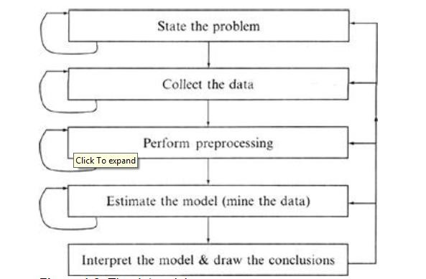

The Data mining Process

**1.6 Classification of Data mining Systems:**

The data mining system can be classified according to the following criteria:

 Database Technology

 Statistics

 Machine Learning

 Information Science

 Visualization

 Other Disciplines

**Some Other Classification Criteria:**

 Classification according to kind of databases mined

 Classification according to kind of knowledge mined

 Classification according to kinds of techniques utilized

 Classification according to applications adapted

**Classification according to kind of databases mined**

We can classify the data mining system according to kind of databases mined. Database system can be classified according to different criteria such as data models, types of data etc. And the data mining system can be classified accordingly. For example if we classify the database according to data model then we may have a relational, transactional, object- relational, or data warehouse mining system.

**Classification according to kind of knowledge mined**

We can classify the data mining system according to kind of knowledge mined. It is means data mining system are classified on the basis of functionalities such as:

 Characterization

 Discrimination

 Association and Correlation Analysis

 Classification

 Prediction

 Clustering

 Outlier Analysis

 Evolution Analysis

**Classification according to kinds of techniques utilized**

We can classify the data mining system according to kind of techniques used. We can describe these techniques according to degree of user interaction involved or the methods of analysis employed.

**Classification according to applications adapted**

We can classify the data mining system according to application adapted. These applications are as follows:

 Finance

 Telecommunications

 DNA

 Stock Markets

 E-mail

**1.7 Major Issues In Data Mining:**

* **Mining different kinds of knowledge in databases.** - The need of different users is not the same. And Different user may be in interested in different kind of knowledge. Therefore it is necessary for data mining to cover broad range of knowledge discovery task.
* **Interactive mining of knowledge at multiple levels of abstraction.** - The data mining process needs to be interactive because it allows users to focus the search for patterns, providing and refining data mining requests based on returned results.
* **Incorporation of background knowledge.** - To guide discovery process and to express the discovered patterns, the background knowledge can be used. Background knowledge may be used to express the discovered patterns not only in concise terms but at multiple level of abstraction.
* **Data mining query languages and ad hoc data mining.** - Data Mining Query language that allows the user to describe ad hoc mining tasks, should be integrated with a data warehouse query language and optimized for efficient and flexible data mining.
* **Presentation and visualization of data mining results.** - Once the patterns are discovered it needs to be expressed in high level languages, visual representations. These representations should be easily understandable by the users.
* **Handling noisy or incomplete data.** - The data cleaning methods are required that can handle the noise, incomplete objects while mining the data regularities. If data cleaning methods are not there then the accuracy of the discovered patterns will be poor.
* **Pattern evaluation.** - It refers to interestingness of the problem. The patterns discovered should be interesting because either they represent common knowledge or lack novelty.
* **Efficiency and scalability of data mining algorithms.** - In order to effectively extract the information from huge amount of data in databases, data mining algorithm must be efficient and scalable.
* **Parallel, distributed, and incremental mining algorithms.** - The factors such as huge size of databases, wide distribution of data, and complexity of data mining methods motivate the development of parallel and distributed data mining algorithms. These algorithms divide the data into partitions which is further processed parallel. Then the results from the partitions is merged. The incremental algorithms, updates databases without having mine the data again

from scratch.

**1.8 Knowledge Discovery in Databases (KDD)**

Some people treat data mining same as Knowledge discovery while some people view data mining essential step in process of knowledge discovery. Here is the list of steps involved in knowledge discovery process:

1. **Data Cleaning** - In this step the noise and inconsistent data is removed.
2. **Data Integration** - In this step multiple data sources are combined.
3. **Data Selection** - In this step relevant to the analysis task are retrieved from the database.
4. **Data Transformation** - In this step data are transformed or consolidated into forms appropriate for mining by performing summary or aggregation operations.
5. **Data Mining** - In this step intelligent methods are applied in order to extract data patterns.
6. **Pattern Evaluation** - In this step, data patterns are evaluated.
7. **Knowledge Presentation** - In this step, knowledge is represented.

The following diagram shows the process of knowledge discovery process:

